Project Specification - Lost & Confused
Names: Michael Panuganti, Avaneeth Kumar, Tristan Lim
Period 4
Overall Description
Lost & Confused is a geolocation game where players see panoramas of places in the real world (using Google Street View) and have to guess where the location is in the world by placing a pin on the world map. Players can move around from the location they start at, looking for clues to help them decipher their location.

In a single game, there will be multiple rounds, each of which has a different location that the player needs to guess. Once the player makes the guess, they can end the round. After the round is finished, the player will be shown the distance that their guess was from the actual location.

Once the player enters the game, a panorama view of their location will be opened in one window, and another window will open containing the map on which the players will place a pin to mark their guess. At the end of each round, the actual location will also be revealed, as well as the distance between it and the player’s guess. From there, the player will have an option to begin a new round, or an option to finish the game. If the player ends the game, they can review their rounds using next/previous buttons.
Class/Interface Overview
Top Level Class
Game - creates the actual window that the game will be played in. The window will incorporate a map and buttons to make the guess. In addition, another window is launched from this class in which the panorama will be shown. Game also consists of the code to make sure everything is synchronized (e.g. map and panorama point to the same location).

Major Classes
Map - will show a map on which pins can be placed. The map will store the location of the pin in latitude and longitude coordinates as well.

Panorama - displays a panorama of a location given specific latitude and longitude coordinates. Will be achieved using a browser which loads Google Street View.

Minor Classes

Round - Object which represents an individual round in a game, where data such as the actual location, player guess, and distance will be stored to be displayed at the very end.

Utilities - contains functions that will be used by the Game class. For example, a function to find distances between longitudinal points, a function to generate coordinates, and a method to check if the coordinates are valid within google maps streetview.

GUI Classes
MyWaypointRenderer - Part of the GUI that can place Red pins (for marking the actual location) or Blue pins (for marking the player’s guess) onto the map.

PathPainter - Draws a dotted line between the actual location and the player’s guess on the result screen of the game.

WaypointListener - Uses mouse input (right click) to place down a pin on the map and also remove previous pins if applicable.

Class Diagram
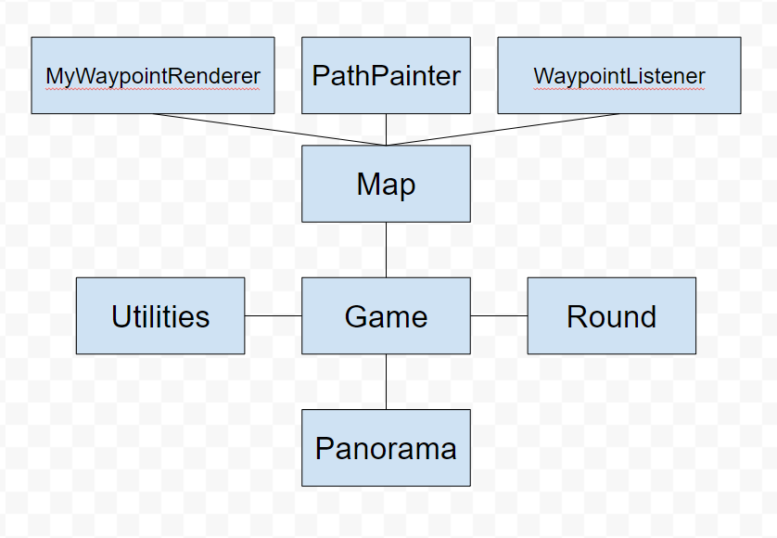

High Level Major Class Specifications

Map
- Attributes
- private JXMapViewer viewer;
- private compoundPainter<JXMapViewer> painter;
- private WaypointPainter<Waypoint> bluePins;
- private WaypointPainter<Waypoint> redPins
- private PathPainter paths;
- Methods
- public JXMapViewer getViewer()
- public void enablePinPlacing()
- public void disablePinPlacing()
- public GeoPosition getBluePinPosition()
- public void placeBluePin(GeoPosition p)
- public void placeRedPin(GeoPosition p)
- public void drawPath(GeoPosition p1, GeoPosition p2)
- public void clearOverlay()
Panorama
- Attributes
- private static final String PANO_PATH;
- private Integer procID;
- Methods
- public void launchPano(GeoPosition p)
- public void terminatePano(GeoPosition p)
Utilities
- Attributes
- public static final String API_KEY;
- public static final double MIN_LAT;
- public static final double MAX_LAT;
- public static final double MIN_LON;
- public static final double MAX_LON;
- Methods
- public static GeoPosition generatePosition()
- public double calculateDistance(GeoPosition p1, GeoPosition p2)
- private static double myRandom(double low, double high)
- private static boolean validateCoordinates(double lat, double lon)

Round
- Attributes
- private GeoPosition guess;
- private GeoPosition location;
- private double distance;
- Methods
- public GeoPosition getGuess()
- public GeoPosition getLocation()
- public double getDistance()

Data Structure:
We decided to use a LinkedList<Round> to store all of the data from previous rounds. Because our game can theoretically go on for as many rounds as possible, we decided not to use an arrayList since it would have to keep on resizing itself. Each round stores the values of the GeoPositions of the player's guess, the actual location, and the distance between the two. By having a LinkedList of every round, the player can click finish game to review their scores and see how well they guessed on each round. It is very easy to iterate through the list whether the player needs to go forwards or backwards. We think this is the best strategy for what we are trying to achieve with the end screen after the game is over.

